31.1: a) 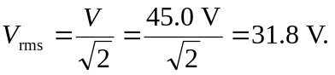
b) Since the voltage is sinusoidal, the average is zero.

